**Case Study Subjective Questions**

1. Which are the top three variables in your model which contribute most towards the probability of a lead getting converted?

**Answer:**

1. Total Time Spent on Website
2. Lead Origin_Lead Add Form
3. TotalVisits
4. What are the top 3 categorical/dummy variables in the model which should be focused the most on in order to increase the probability of lead conversion?

**Answer:**

1. Lead Origin_Lead Add Form
2. Last Notable Activity_Unreachable
3. What is your current occupation_Working Professional
4. X Education has a period of 2 months every year during which they hire some interns. The sales team, in particular, has around 10 interns allotted to them. So during this phase, they wish to make the lead conversion more aggressive. So they want almost all of the potential leads (i.e. the customers who have been predicted as 1 by the model) to be converted and hence, want to make phone calls to as much of such people as possible. Suggest a good strategy they should employ at this stage.

**Answer:**

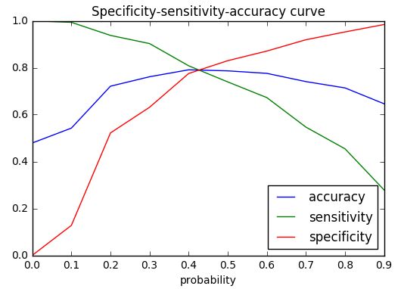

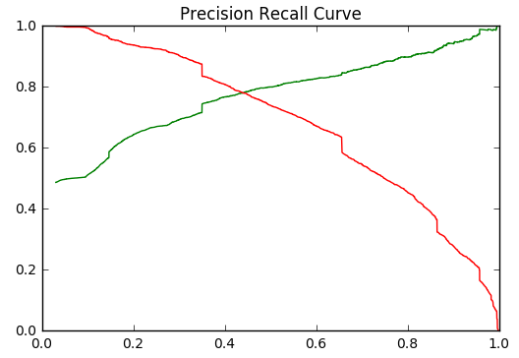

We need to increase the leads in this case, i.e. to reduce the cutoffs so that model predicts more leads. Thus we reduce the cutoff by higher sensitivity and lower precision and found the most appropriate candidates.

1. Similarly, at times, the company reaches its target for a quarter before the deadline. During this time, the company wants the sales team to focus on some new work as well. So during this time, the company’s aim is to not make phone calls unless it’s extremely necessary, i.e. they want to minimize the rate of useless phone calls. Suggest a strategy they should employ at this stage.

**Answer**:

In this case we need to increase the cuttoffs so that the leads who score the highest will be considered. When we increase the cutoff it will result in higher precision which means that the leads which are predicted as yes by the model will convert, while the sensitivity will fall and can lower the lead score slightly.